**EVENT MANAGEMENT SYSTEM**

**Group Members**

Archit Kak - AM.EN.U4CSE20311

Ananthakrishnan K M - AM.EN.U4CSE20307

Nayan Thara M - AM.EN.U4CSE20347

**ABSTRACT**

The Event Management system is a smart web application that allows users and management to meet at a very flexible place. In this application, users need to be registered and get a login. After login, users will be provided with a user ID. Users must register with the necessary details about the venue and the event to be organized. A request will be generated automatically and will be sent to the admin.

The admin will see the user request and he will send the request to management and they will see the availability according to the date if they accept the same will be sent to the user.

The user can see his status in the application if the booking was confirmed and the same will be shown.

***Keywords: Event Management system,admin,request,management***

**Functional Requirements of the System**

1. Users need to register with the system before using the application.
2. Users want to log in to the system to access his/her main page.
3. Users can view personal details.
4. Admin wants to log in to the system to get his/her administrative privileges.
5. Admin can forward the user request to management and also view the **staff list** and **client list**.

**Use cases**

Requirement analysis of our system and listed valid use cases here.

1. Login

2. View

3. Edit

4. Delete

5. Register

6. Verify

7. Logout

**Actors**

1. **Admin:**

Admin needs to login into the application using the username and password and he can view the registered users and registered employers. Admin can also view the requests sent by the user and will forward them to the management and the rest is done by the management if the management accepts the request the same will be shown in admin saying that management is ready to accept the request and finally admin needs to accept and the booking is confirmed.

1. **Management:**

Management needs to register for the application before getting logged in. After getting logged in the application welcomes management with the management home screen, showing the functionalities of the organizer. He can add venues and view the user requests which are forwarded by the admin. He can also view the feedback given by the user.

1. **User:**

The user needs to be registered into the application before getting logged in, after getting the login access user will search for the venues based on the location, the user will select the address on the map. Then the user will see the list of events available in that location and the user can book any one of them the request will be forwarded to the admin, the admin will again forward the request to the particular organizer who is conducting the event if he accepts the admin request the admin will confirm the same to the user. The user can see the booking status whether the event is confirmed or not. The user will also receive the mail that the booking is confirmed.

**Use Case Description**

|  |  |
| --- | --- |
| Use Case | Login |
| Actor | Admin, Management, User |
| Inputs | Username and Password |
| Outputs | The system will state whether inputs are correct or not. A user id is automatically allocated for a user. |
| Description | The actor must have signed in to the system and have a valid username and password.  The actor can log in to the first form by entering the username and password. If a valid actor, display the dashboard of the respective actor, but if the actor entered the wrong username or password then he/she will be an invalid user and will see an alert message “Invalid Username and Password” and to log in again or sign in to create a new account. |

|  |  |
| --- | --- |
| Use Case | View |
| Actor | Admin, Management, User |
| Outputs | The system will state the actor’s information |
| Description | The actor must have signed in to the system and have a valid username and password.  The actor can view his details and based on the role it changes as stated in the functional requirements of the system. Each actor has different homepages and functionalities. |

|  |  |
| --- | --- |
| Use Case | Edit |
| Actor | Admin, Management, User |
| Outputs | The system will state the actor's profile and an option to edit. |
| Description | The actor must have signed in to the system and have a valid username and password.  They have an option to edit their profile information and based on their roles they can change different stuff after successfully logging in to the system. |

|  |  |
| --- | --- |
| Use Case | Delete |
| Actor | Admin |
| Outputs | The system will state the delete option for the respective actor. |
| Description | The user must have signed in to the system and have a valid username and password.  Admin can delete a user and his requests |

|  |  |
| --- | --- |
| Use Case | Register |
| Actor | User |
| Inputs | Username, Password, and other necessary details based on the role |
| Outputs | The system will return a successful message once after registration |
| Description | The actor must have a valid username and password.  The actor can register the first form by entering the username, password, and necessary details. Once after registration, the actor will be redirected to the login form and details should be entered again for a successful login. |

|  |  |
| --- | --- |
| Use Case | Verify |
| Actor | Admin, management |
| Inputs | Username, Password, and other necessary details based on the role |
| Outputs | The system will return a verified message and the user will be alerted that their order is placed. |
| Description | The actor must have a valid username and password.  The actor must log in by entering the username, password. Then verify the user request according to the availability of the date. The admin will finally confirm the request and send it back to the user. |

|  |  |
| --- | --- |
| Use Case | Logout |
| Actor | Admin, Management, User |
| Outputs | The system will log out the actor. |
| Description | The user must have signed in to the system.  The actor can log out from the system and a prompt will be shown with confirmation “Do you want to log out”, after giving yes the actor will be successfully logged out. |

**Use case Diagram**

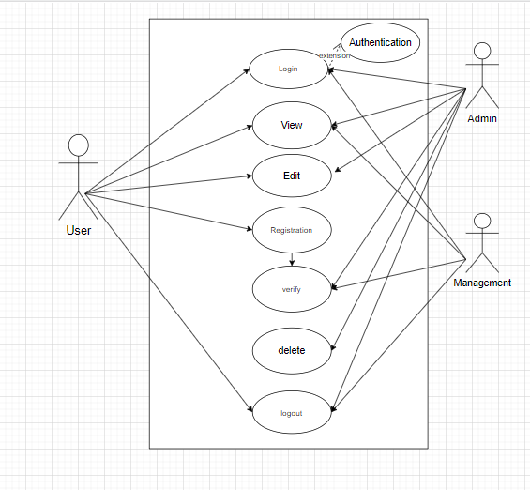

**User Interface Design**

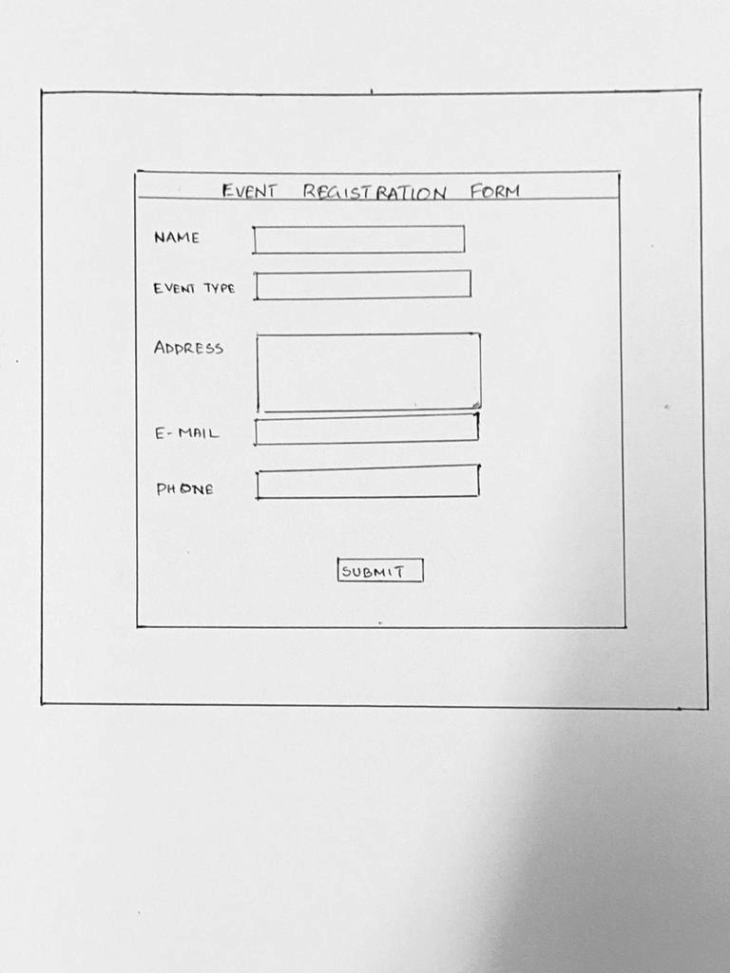

**Class Diagram**

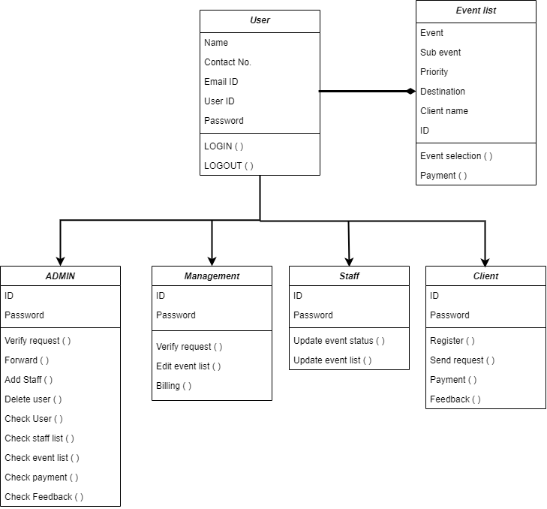

Changes here:-

https://docs.google.com/document/d/1O2YQPWOwZg97BhDiSPmFROD6YtmfLhdqC8KWVW1l6MU/edit?usp=sharing